To: xxxxxxxxxx

Cc :

Commissioner Vella

Commissioner Andriukaitis, DG ENV, DG SANTÉ

**Call for clean air**

*Open letter by 76 public health, environmental, civil society, organic farming and animal welfare organisations on the opening of the trilogue negotiations on the National Emissions Ceilings Directive*

+++++Date+++

Dear Ministers,

This week you will be starting the trilogue negotiations for the new EU National Emissions Ceilings Directive (NEC). The NEC is a unique opportunity to set the EU on track for clean air and save literally thousands of lives of European citizens each year.

**In the EU, air pollution continues to be an “invisible killer” causing 403,000 premature deaths in the year 2012 alone.** Poor air quality also contributes to severe chronic disease including cardio-vascular and respiratory disease such as asthma, allergies, chronic obstructive pulmonary disease (COPD), lung cancer, impaired prenatal and early childhood development, and other chronic conditions such as diabetes, liver disease, mental health, obesityand childhood leukaemia. The health-related economic costs of air pollution are estimated at between €330 - €940 billion for the EU annually, which is equivalent to 3 - 9% of the EU’s GDP. Air pollution also impacts Europe’s nature and biodiversity, agricultural yields and natural vegetation. Crop losses due to air pollution are estimated at €3 billion per year in 2010.

The European Commission has put forward proposals which would help tackle the severity and pervasiveness of air pollution as a public health emergency. We welcome this move and the improvements proposed by the European Parliament, in particular its call for earlier action. We are seriously concerned by the Council’s intention of weakening the overall ambition level, which will cause approximately 16,000 additional early deaths each year.[1] We are also alarmed by the high number of derogations and flexibilities introduced by the Council which undermine the whole purpose of the Directive to reduce air pollution and prevent premature deaths.[2]

**We, the undersigned public health, environmental, civil society organisations ask you to support the following five priorities for the trilogue negotiations:**

1**. Support emission reduction commitments corresponding to at least 52% health improvement by 2030 EU-wide** as proposed by the European Commission and the European Parliament - notably no weakening of ammonia and PM2.5 emission reduction commitments.

2. **Support legally binding targets for 2025 as requested by the European** **Parliament**. Early action to tackle air pollution must be a priority; waiting until 2030 will prolong premature deaths.

3. **Reject unnecessary flexibilities**, such as the adjustment of emission inventories, adjustment of emission factors and three-year averaging calculations, which are not justifiable and will dilute the ambition level of the Directive.

4. **Keep methane emission reduction commitments** in the Directive as a way of tackling ground-level ozone. We also call upon the Commission to **address harmful mercury emissions when reviewing the Directive.**

5**. Support provisions granting the public the right to access to information,** to participate in the formulation of national air pollution control programmes and to access the courts if their governments fail to comply with the Directive**.**

Breathing clean air is one of our most fundamental human needs. Every EU citizen has the right to grow up, live and work in an environment which promotes their health rather than threatening it.

**Achieving good air quality requires strong action and commitment at EU level. The time to take this action is now. Each delay will result in additional unnecessary deaths, increased health impacts and suffering, and continued strain on healthcare budgets.**

Thank you in advance for your support.

Yours sincerely,

**SIGNATURE**

**NAME**

ON BEHALF OF:

European Environmental Bureau - EEB

Health and Environment Alliance - HEAL

Air Pollution & Climate Secretariat – AirClim

Client Earth

Transport and Environment - T&E

Greenpeace

BirdLife Europe

World Wild Fund for Nature Europe - WWF

The European Public Health Alliance - EPHA

The European Respiratory Society - ERS

European Federation of Allergy and Airways Diseases Patients Associations - EFA

Compassion in World Farming - CIWF

EU Federation of Organic Agriculture Movements - IFOAM – EU

European COPD Coalition - ECC

Change Partnership

Naturschutzbund Deutschland - NABU, Germany

ÖKOBÜRO, Austria

VCÖ – Mobilität mit Zukunft, Austria

Legambiente, Italy

Friends of the Earth Germany - BUND, Germany

Ecologistas en Acción, Spain

Deutsche Umwelthilfe - DUH, Germany

Cittadini per l’aria, Italy

Clean Air Action Group, Hungary

Clean Air in London, UK

Danish Ecological Council, Denmark

Milieu Defensie, the Netherlands

Finnish Association for Nature Conservation - FANC, Finland

Der Deutsche Naturschutzring - DNR, Germany

Fundación Alborada, Spain

Fédération SEPANSO Aquitaine, France

ÄrztInnen für eine gesunde Umwelt – AeGU, Austria

MOBilisation for the Environment, Netherlands

Martorell Viu, Spain

Instituto Internacional de Derecho y Medio Ambiente - IIDMA, Spain

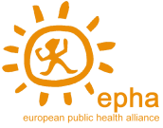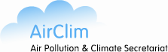

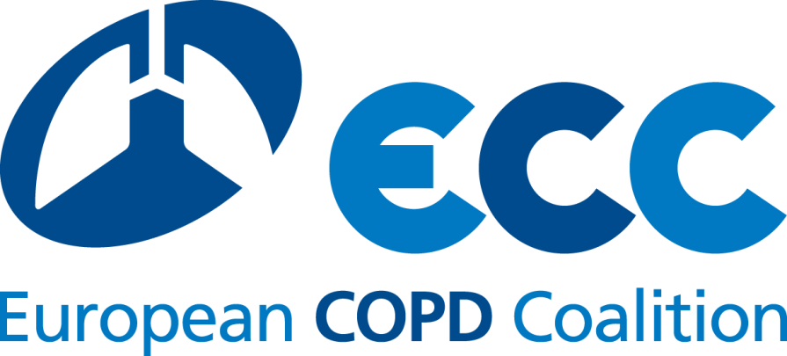

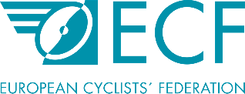

1. In his speech at the Environment Council’s debate on 16 December 2015, EU Environment Commissioner Vella estimated that every percentage change from the 52% health improvement target proposed by the Commission would result in around 4,000 additional premature deaths in the year 2030. The four percentage cut proposed by the Council is therefore estimated to cause around 16,000 additional premature deaths in the year 2030.
2. NGO comments about the different flexibilities proposed by the European Commission and Council can be found here: http://www.eeb.org/index.cfm/library/flexibilities-in-the-national-emission-ceilings-nec-directive-undermining-effective-law-making/