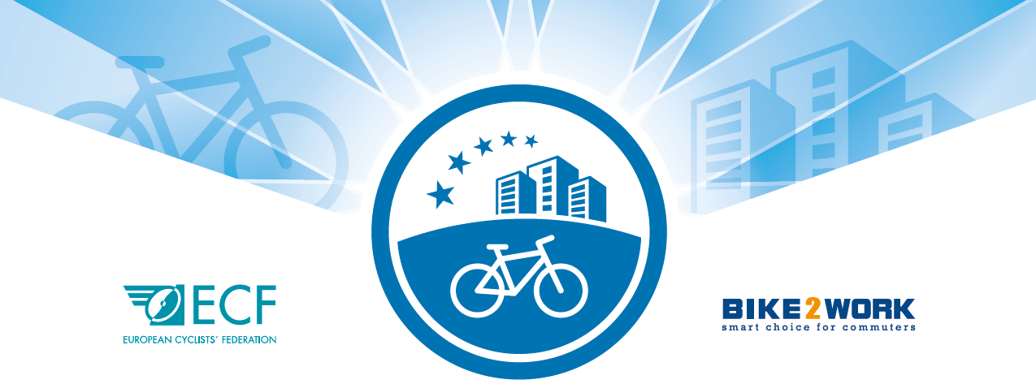

CFE Consortium membership

Call for Applications 2020

***

Business Plan Template

INSTRUCTIONS
- Please use the templates below as guidelines in preparing your application.
- Please submit your business plan within three weeks of positive evaluation of your application form.
- For any questions, and for submission of your final document, contact Froso Christofides, f.chirstofides@ecf.com, ECF Project Manager & CFE Secretariat.

BUSINESS PLAN

SUMMARY

BUSINESS IDEA & SERVICES | Customer needs and proposed solutions
Services
- Certification cycle-friendly employer
- Consulting/ other?
 | Uniqueness and innovation in approach
 | Protection strategy
MARKETING & PROMOTIONAL STRATEGY | Market analysis
 | Industry and competitors
Target market
- Positioning against competitors
- Sales volume
 | Marketing strategy
OPERATIVE CAPACITY | Business model
Responsibilities
- Tasks in detail
- Staff
- Training for consultants/ auditors
 | Main partners and stakeholders
IMPLEMENTATION TIMETABLE | Status of services
 | Cornerstone of the sales concept
RISKS | Exit strategy
FINANCIAL SUSTAINABILITY | Central assumptions
 | Break-even point
 | Capital requirements
 | Profit year 1 to year 3
 | Sales by source
 | Detailed cost plan

BUDGET
 | Year 1 | Year 2 | Year 3
 | 2020 | 2021 | 2022
Sales
Certifications
Consultations
Re-Certification
Online Re-Certification
Logo license per year
Total Sales
Fixed Costs
Salary coordinator
Sales/Customer Service
Marketing/PR
Accounting
Phone/internet
Rent
Licenses
Office materials
Subtotal Fixed Costs
Variable Costs
External service (Certification)
External service (Online Re-Cert.)
External service Re-Certification
External service (Consultation)
Postage
Certificate
Training
Events
Travel costs
Subtotal Variable Costs
Total Sum Costs
Revenue/Loss

