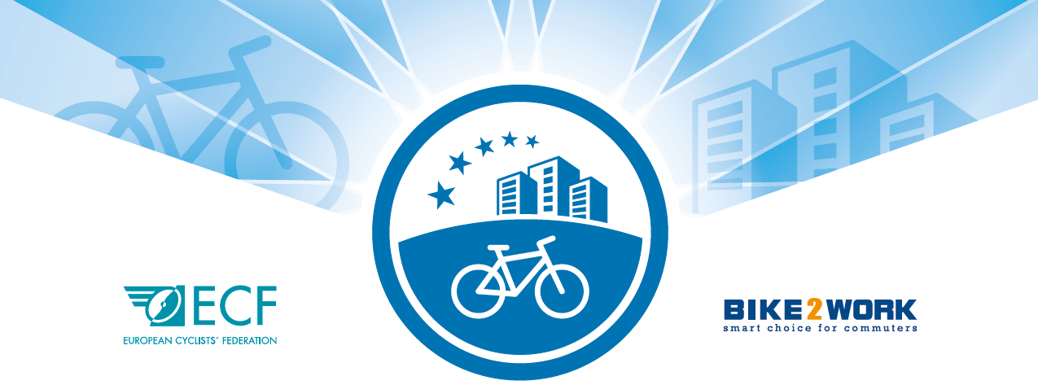

CFE Consortium membership

Call for Applications 2020

***
APPLICATION FORM

INSTRUCTIONS
- Please read the CFE Consortium - Call for applications 2020 and its supporting documents.
- Only applications using this form will be accepted.
- Please do not send additional documents of any kind, these will not be considered.
- Please complete and send the application form to the CFE Secretariat - Ms. Froso Christofides, f.christofides@ecf.com
- Each Section should not exceed 1-page A4.
- NOTE: in case of positive evaluation, your organization will be invited to submit a 3-year business plan as defined in the CFE Call for Applicants 2020.

SECTION 1 – ADMINISTRATIVE INFORMATION
Country
Name of the organization(s) (English)
In case of consortium, please list all the organisations involved and mention the name of the consortium.
Name of contact person
Position in organization
Phone number
E-mail
Web site home-page(s)
Skype address
Eligibility: | ☐ Legal entity  ☐ Consortium
Eligibility: based in the country for which you apply  In case of consortium, at least two organisations must be based in the related country. | ☐ Yes  ☐ No
Eligibility: type of entity
In case of consortium, please specify the type of entity for each organisation involved.

SECTION 2 – BUSINESS IDEA AND SERVICES
Describe the 3-year work plan to implement the CFE Certification scheme in your country, defining tasks and responsibilities, impact on the diffusion and acknowledgement of the CFE Certification scheme, and measurable indicators for the period 2020-2022.

SECTION 3 – MARKETING AND PROMOTIONAL STRATEGY
Outline the marketing and promotional strategy, define the main target groups and stakeholders. Describe the activities, tools and expected results of your strategy.
SECTION 4 – OPERATIVE CAPACITY
Describe qualifications and professional experiences of the staff primarily involved in the implementation of the CFE Certification scheme. Furthermore, list previous actions/activities performed and connected to the cycling friendliness, in particular those regarding the management of bike-to-work schemes and/or company-certification.

SECTION 5 – FINANCIAL SUSTAINABILITY
Provide an overview of the estimated budget, including costs and income for the 3-year period of implementation, and explain how it will ensure the financial sustainability of the CFE Certification scheme in your country.
SECTION 6 – IMPLEMENTATION TIMETABLE
Please make a detailed timetable that includes the activities of the proposed work plan as listed above and indicate milestones. Please take into consideration that a technical and financial report will be requested by the CFE Consortium after the end of each year as well as an update of the business plan.
DATE | ACTIVITY | ORGANISATION/  STAFF IN CHARGE

SECTION 7 – ESTIMATED BUDGET 2020 - 2022
The estimated budget provides forecasts on the following:
- Central assumptions
- Break-even point
- Capital requirements
- Profit year 1 to year 3
- Sales by source
Please use the following table for your estimated budget (2020-2022):
COSTS |  | INCOME
Staff costs | € - | CFE Certifications | € -
Subcontracting | € - | Sponsorships | € -
Travel | € - | Other incomes | € -
Other costs | € - |  | € -
CFE Common pot | € - |  | € -
TOTAL COSTS | € - | TOTAL INCOME | € -
 |  | PROFIT OR LOSS | € -

