Grant agreement no: | IEE/10/277/SI2.589419
Project acronym: | Cyclelogistics
Project title: | Moving Europe forward

D3.6 Campaign Scheme
Shop-by-Bike

Start date of the action | 03.05.2011 | Duration: | 36 months
End date of the action | 04.05.2014
 |  | Version: | 1
 |  | Prepared by: | Susanne Wrighton
 |  | Checked by:
Due date | January 2012 | Verified by:
 |  | Status: | draft
 |  | Dissemination level: | PU
Project coordinator | FGM-AMOR
Karl Reiter |  | reiter@fgm.at | +0043 316 810 451 23

www.cyclelogistics.eu

Table of content

1. Background 4
2. Application areas 4
3. Potential for goods transport by bicycle in general 5
4. Underestimated potential of shopping traffic of private individuals 5
4.1. Private individuals 5
4.2. Retailers and municipalities 7
5. What can retailers do? 9
6. What can municipalities do? 10
7. What can society do? 11
8. General campaign scheme 11
8.1. CycleLogistics – Shop-by-Bike campaign 11
9. Campaign schemes in the various partner countries 13
9.1 Austria 13
9.2 Belgium 13
9.3 UK 13
9.4 Italy 13
9.5 Bulgaria 14
9.6 Denmark 14
9.7 Romania 14
9.8 The Netherlands 14
9.9 Slovenia 14
9.10 France 14
9.11 Croatia 14
10. Annex - Best practice examples 15
Belgerinkel 15
Bicycle delivery Service in Switzerland 16

1. Background
European cities suffer from an unsustainable yet ever increasing problem of traffic congestion, carbon emissions and noise pollution and hence a loss in the quality of life, especially in inner city areas. All these problems are to a large extent due to a still growing motorization.
The project CycleLogistics aims to achieve a reduction in energy used and carbon emissions produced by urban freight transport by shifting some of the intra-urban final delivery of goods from cars and lorries to bicycles. This will be achieved by:
- Integrating bicycle logistics in municipal policies and urban transport plans
- Achieving large scale application of transport cycle for community and business services. This can be accomplished by amending the local transport policies in a way that is favourable for deliveries done by bike (and unfavourable for cars & trucks)
- Optimizing/Improving upon conditions for shoppers by increasing bike infrastructure and services at supermarkets and shops.
In order to achieve this last point in the long-run, 15 “Shop-by-Bike” campaigns will be carried out in the various partner counties. The aim of these campaigns is not only to raise awareness and to demonstrate to the population that bicycles are often the most efficient vehicle to transport shopping goods or leisure time equipment, but also to determine the infrastructural requirements and services for customers that shop by bike at the supermarkets and shops. This acquired knowledge will be used to sensitize shop owners to the needs of this customer group and to promote this type of shopping among the population.

2. Application areas
The CycleLogistics project is divided into the following application areas:
- Application area 1: Goods delivery
- Application area 2: Municipal & Business services
- Application area 3 Private goods Transport
- Application area 4: Consumer Tests
Application area 1 will focus on bicycle goods delivery companies and bike courier services to improve and professionalise existing services and raise interest within existing logistic companies to use cargo bikes and bicycle trailers for the delivery of goods.
Application area 2 will push towns & cities to replace unneeded motor vehicles and use cargo bike to provide Municipal services (e.g. street cleaning, park maintenance etc.) and at the same time service providers (e.g. tradesman, window-cleaners, plumbers, etc.) will be encouraged to provide their services by bike.
Application area 3 will tap into the huge potential for private individuals to use the bike to transport goods by demonstrating how easy it is to equip a bicycle with baskets, panniers or a bicycle trailer in order to take home daily supplies and other shopping goods and transport their leisure equipment. Here, supermarkets and retailers will also be encouraged to provide favourable frame conditions for cycling customers.
Application area 4 will provide necessary and useful information for potential users of cargo bicycles or private individuals wanting to use their bicycle with the appropriate equipment for goods transport. Consumer tests of bicycles and equipment will be carried out and published.

3. Potential for goods transport by bicycle in general
There is a huge potential for CycleLogistics to shift shopping transport away from motorized vehicles towards cycling-related solutions. 57 % of all inner-city trips are related to goods transportation in some way. This includes the delivery of goods as well as the transport of materials and tools for the provision of a service. Almost
100% of these trips within cities are done by motorized vehicles and often light goods are transported by heavy vehicles for short distances. But also within the area of private logistics, e.g. shopping trips and transport of goods by private individuals, predominantly motorised vehicles are uses.

4. Underestimated potential of shopping traffic of private individuals

4.1. Private individuals
Shopping transport with a share of 23% of all urban trips is associated with the transport of goods in 4 out of 5 cases. Research shows that a car is only required for 6% of all shopping trips. [ARGUS 2009]

Figure 1: Lots of potential

A survey, carried out in Graz in 2009, had surprising results: it turned out that 80% of 1600 purchases from shopping trips could have been transported on a bicycle. In 14% the volumes were so big that it would have required a bicycle trailer and only in 6% of the cases a car would have been necessary to transport the purchases home. Despite that 77% of all these shopping trips were done by car. .
The majority of all shopping trips involve the transport of daily goods (food and toiletries) [Reiter and Pressl, 2009]. In fact, 85% of shopping trips are done for daily supplies, available in supermarkets. In urban areas supermarkets are usually located within the catchment area of bicycle traffic. 10% are related to durable consumer goods (e.g. clothing) and only 5% are related to goods like furniture, equipment etc. Therefore, the existing data demonstrate a high potential for shopping transport, both, with regard to transport volumes and the trip distance.

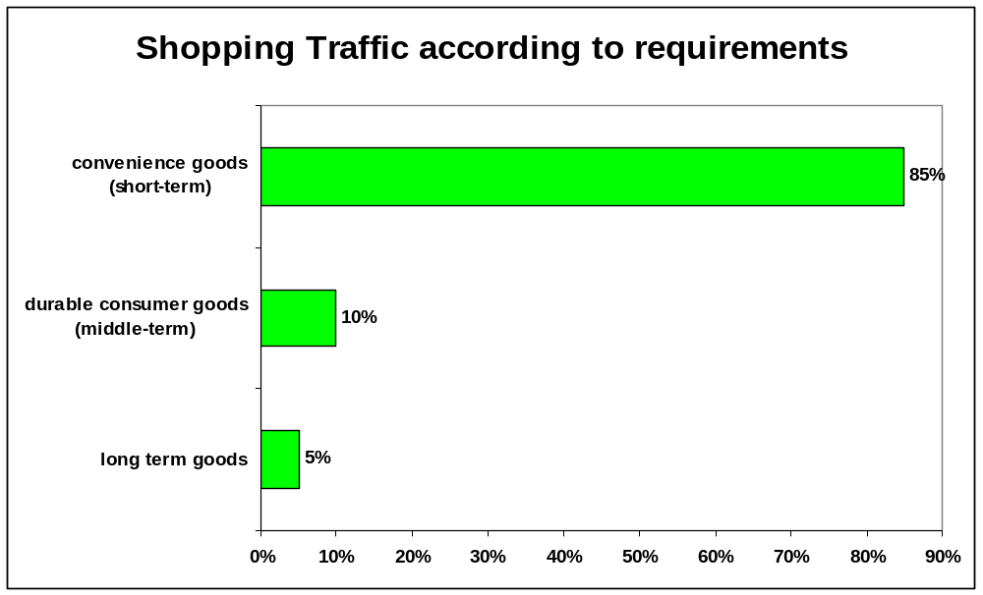
Figure 2: Shopping traffic according to requirements
According to a nation-wide mobility survey in Germany [Mobilität in Städten, 2008] only 11% of all shopping trips are done by bicycle, compared to 18% of all trips to work and 17% of all leisure trips.

Important messages
- The majority of shopping trips (85%) are trips to buy convenience goods.
- The majority of all shopping (80%, convenience and durable consumer goods) can be transported on a bike, e.g. in baskets, panniers or trailer
- The majority of all shopping trips are short distance trips (every second trip shorter than 5 km)

4.2. Retailers and municipalities
A lot of information is also still needed to convince retailers, municipalities and local politicians in many European countries. Because the purchasing power of cyclists is highly underestimated and shop keepers generally focus on motorists as their main customers. Car parking spaces and accessibility for cars is usually their primary aim. They have not yet realised that cyclists have at least the same spending power as motorists and constitute a growing market segment in European inner cities.
Another study in Bristol (UK) shows how big the gap between reality and perception can be. When retailers were asked to estimate how many of their customers life in a radius of half a mile of their shop and further than two miles, they answered 12% and 40%. In reality however, 42% of the customers lived within a radius of half a mile and 86% not further than 2 miles away! These are distances ideal for cycling and hence for shopping by bike.
In Austria [Georg Gumpinger, 2010] it could be demonstrated that 80% of cyclists visit local shops several times a week. For motorists this number is only 68%. Cyclists are also very loyal customers. Today many people who cycle decide for this mode of transport not because they cannot afford a car. People using their bicycle to do their shopping do so mainly by visiting shops located close to their home or workplace within inner cities and residential areas for daily supplies. For this reason, local shops and retailers have an advantage compared to shopping malls and supermarkets at the outskirts of towns.

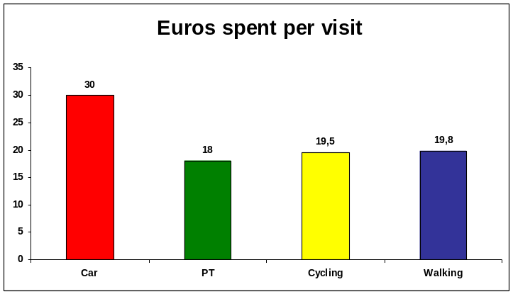
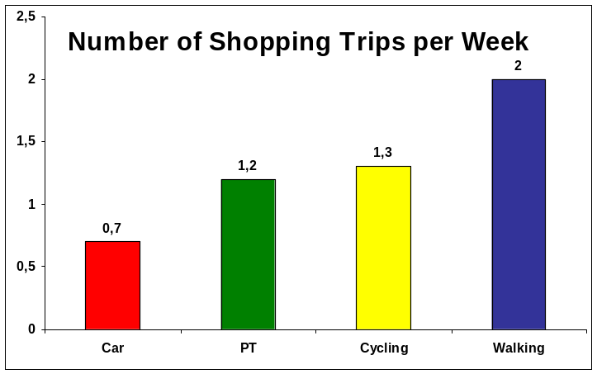
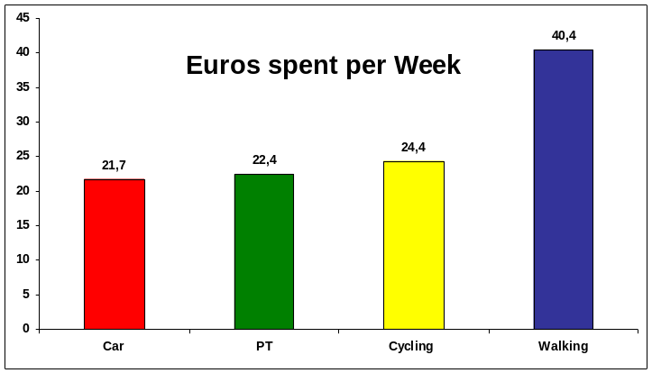
Figure 3: Survey in 6 French towns [Brichet 2003]
With more cycling customers retailers can also save on costs for parking spaces. Because 6-9 bicycles fit into one car parking space and therefore lead to potential cost savings for parking spaces. An interesting survey in the City of Bern (Switzerland) analysed the relationship between profitability of purchases and the costs for customer parking spaces: calculated like this cyclists are worth 7.500 m² for retailers, while motorists are only worth 6.625 m².
According to calculations of an Austrian study an increase of the cycling share of 1% would lead to an total additional sales potential for retailers of 0,2%. Medium term it should be possible to shift 10 to 15% of shopping trips currently done by car to the bicycle. This would in turn lead to an additional maximal sales potential for retailers of 1,3 billion Euros. These are magnitudes that should be taken into consideration by retailers when it comes to the improvement of the cycling infrastructure that would make their shops more bicycle-friendly.

Important messages
- Cyclists are good customers with a lot of purchasing power
- More customers live close to the shops than expected
- Cycling customers bring in more sales per square metre of parking area.
From the above mentioned data it becomes very obvious that there is a lot of potential for the bicycle with regard to shopping transport. However, neither decision makers and retailers nor private individuals are totally aware of this potential and how relatively easy it would be to transport daily supplies and other goods by bike, on short trips. In most European cities a lot of awareness raising work needs to be done in this field. And successful strategies to raise the share of cycling traffic and the use of the bicycle for goods transport need the cooperation of several actors: decision makers, retailers, representatives of cycling associations and the private individuals themselves. This is the aim behind the Shop-by-bike Campaign in the CycleLogistics project

5. What can retailers do?
Retailers in inner-city locations have a big interest in improving the quality of their location, to improve the image and to revive the inner cities to address new customer groups and to keep already existing ones. The term for this strategy is accessibility marketing. It is meant to show customers how to reach the shops comfortably and to make it attractive for pedestrians and cyclists to shop in a car-reduced environment close to their homes.
Therefore, it is necessary to provide suitable bicycle parking facilities that are stable, with good visibility and lightning that allow the cyclists to park and secure their bicycles as close to the entrance of the shop as possible. Making these parking facilities weather proof is an added bonus. Because bicycle parking facilities are less expensive than car parking spaces these measures also have positive financial implications for the shop owners.

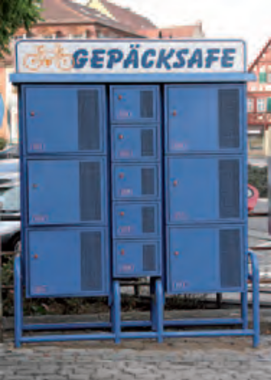 | Other measures that help customers that cycle to the shop are luggage storage facilities that allow them to store their shopping in a safe place while continuing their visit to other shops. These can be luggage safe boxes of various sizes where either shopping bags or helmets, etc. can be stored. Also, delivery services like in several municipalities in Switzerland, where customers can get their shopping delivered by bicycle. This is a joint project of retailers and the social services with long-term unemployed people, for whom these delivery services represent a chance to be reintegrated into society (see Annex, Best Practice examples).  Equally important for cycling customers are service offers within shops that represent a signal of acceptance and appreciation for cyclists, like e.g. “self-help”-stations with air pumps and inner tube dispensers.
Figure 4: Luggage safe

Retailers and shop owners can also show their appreciation for cycling customers by giving them price reductions or small presents. A good example for that is the Austrian town of Bezau (see Annex).

6. What can municipalities do?
An important factor for cities and towns that promote cycling is the continuous creation and maintenance of existing infrastructure on the one hand. On the other hand cycling and other sustainable mobility modes can be promoted with countless innovative information and service offers.
Apart from infrastructural and promotional measures however, municipalities can promote cycling and especially everyday cycling including shopping by bike on various levels by:
- Informing shop owners and retailers about the requirements of cyclists
- Support activities of retailers targeted to cycling customers
- Financially support the acquisition of high quality bicycle parking facilities for shops
- Promote Shop-by-bike campaigns in their municipal media
- Support Shop-by-bike campaigns e.g. with bicycle equipment like bike baskets and panniers
- Include “Shop-by-bike” information in existing bicycle maps (this is especially important information for new citizens and new employees)
- Company-related funding of measures for cycling customers (e.g. funding for bicycle parking facilities)
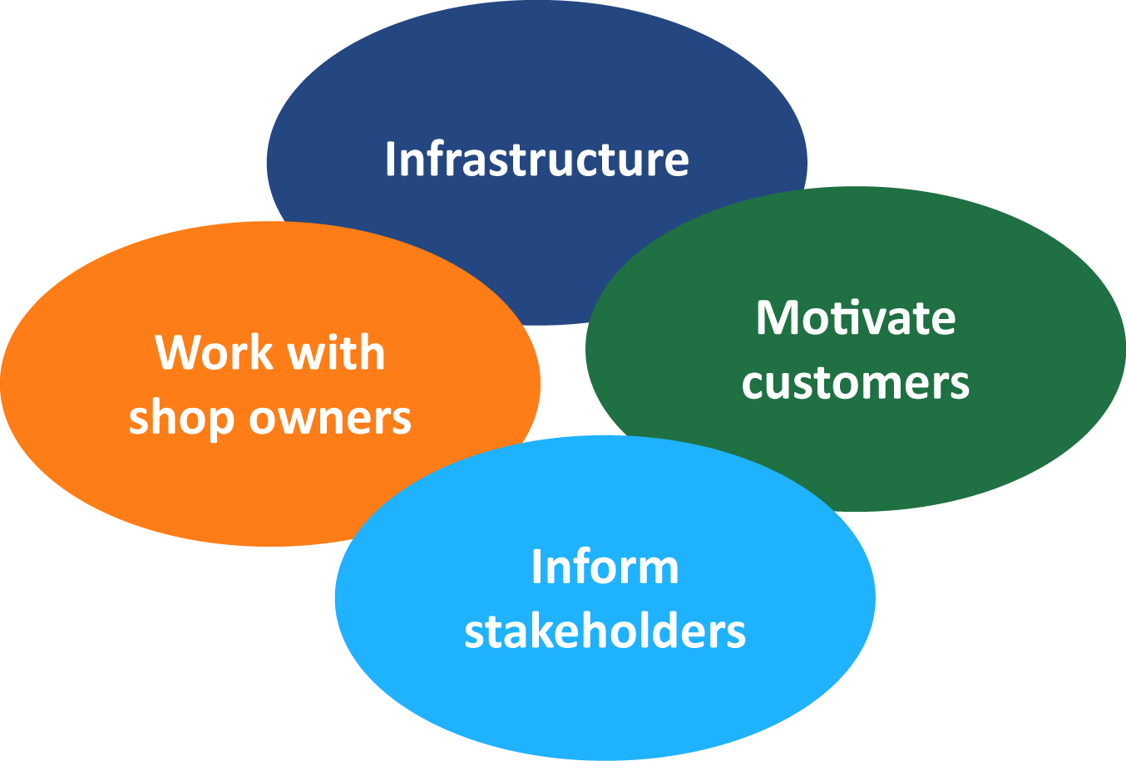
Figure 5: Tasks for municipalities

7. What can society do?
Cycling lobbies, environmental organisations and initiatives usually try to promote the use of bicycles for daily errands, like shopping for daily supplies. They play an important part in initiating political debates and formulating suggestions for improvement.
Often, they also carry out campaigns like “Shop-by-bike” to inform citizens, politicians and retailers about their possibilities and initiate improvements wherever needed.
These campaigns offer individuals to experience how easy it is to use the bicycle for your shopping trip and give valuable information about the necessary equipment, like bicycle baskets, panniers, trailers, etc. that make this task so much easier. The ultimate aim of such campaigns is to give the necessary impetus for motorists to switch to the bicycle for shopping trips. Good examples for this are: Bremen, Darmstadt, Karlsruhe, etc.
Sometimes it is also necessary to change the perception of the public with regard to their mental maps that are often dominated by out of town shopping centres rather than the offer of shops in their closer environment. A project in Hungary, termed “local shopping” aimed to do just that. (See Annex)
Cylcing nations like Denmark, the Netherlands and Belgium of course have a long history of campaigns that reward cycling customers. Good examples for such campaigns are: Belgerinkel, Haal de max uit je fiets, etc. (See Annex)

8. General campaign scheme
Following is the description of a general campaign scheme for a Shop-by-bike campaign, it should be amended according to the particular requirements of the participating partner countries.

8.1. CycleLogistics – Shop-by-Bike campaign

Background
During the EU-project CycleLogistics – Moving Europe forward (www.cyclelogistics.eu) at least 15 Shop-by-Bike campaigns are to be carried out in 11 countries during 2012 and 2013. These Shop-by-bike campaigns consist of test use phases that will last for 1- 2 months, in which about 100 citizens are asked to do their shopping without a car, on their bikes. In total more than 3000 persons will take part in these actions all over Europe. At the beginning of this trial phase the bikes of the test users will be equipped with basket, panniers, trailers, etc. to make this task easy for them. As a target group we not only envisage people already using their bikes for their shopping trips, but also motorists that have to be motivated to try out this new from of transportation.
The aim of this campaign is to change the shopping behaviour of private individuals to the effect that they will use the bicycle more to do their shopping in the future. This would not only increase the quality of live in inner cities but also bring advantages for retailers. For one thing the number of car parking spaces could be reduced. Because despite the fact that cycling customers might buy less than motorists when they visit shops they visit the shops more often and show strong customer loyalty.
To achieve this aim it is important to establish what supermarkets and other retailers can do to make shopping by bicycle more attractive for their customers. During the trial phase it will also be possible for the customers to find out how they can modify their bike, e.g. with bicycle baskets, panniers, better bike stands, trailers, etc. to make it easy to transport home daily goods by bike.

Involved Stakeholders
Supermarkets, Shopping malls, retailers, municipality, bicycle shops, media, cycling associations, NGOs, environmental organisations,

Target Group
Customers of supermarkets, malls, retailers, etc and the shop owners

Organisation and process of the campaign
- Find retailers, shop owners, supermarkets, farmer markets, etc. that will participate in the campaign and also make contact with bicycle dealers that will modify and service the bicycles and rent out the trailers
- Define the various elements of the campaign and the campaign period with participating parties (e.g. supermarkets, retailers, cycle shops, etc.)
- Define/plan how to find test buyers: test persons can be found via various channels; e.g. media (web or print) of the municipality, like district newspapers, environmental or cycling organisations, social medias, Radio/TV, city employees, other campaigns that run at the same time (e.g. “bike to work”), or test persons can be directly addressed in shops or supermarkets by students.
- Interested parties can sign up for participation in the campaign directly in the shop or via a website or phone. When they sign up they can make an appointment to receive a bicycle basket, or panniers or to rent a bicycle trailer at a participating bicycle shop.
- Inspection of the bicycles at a local bicycle dealer. If necessary the bicycle will be modified. E.g. with bike basket, panniers etc. Also, the dealer should inform the participants of the Shop-by-bike campaign how important it is to have a good bicycle stand and tires if you transport heavier goods on the bike. It will also be possible to rent a bicycle trailer for the max. time of one week.
- For the evaluation of the Shop-by-bike campaign specific questionnaires will be handed out, enabling the participants to note down their positive and negative experiences during the trial phase.

Incentive to participate in the campaign
It is necessary to offer the participants of the Shop-by-bike campaign incentives for their participation in the campaign. They could e.g. receive a big bicycle basket (around €20-25) or a 50% discount for saddle bags or panniers (also about €25).
The participants can also rent a bicycle trailer for free (for the maximum of one week) at the participating bicycle dealers.
In analogy to actions like: “How many people fit in a car?” a competition could be carried out among the participants: “How much can I transport on my bike?”

Possible actions of retailers accompanying the campaign
- Creation of infrastructure: bicycle parking spaces for bikes with/without bike trailers and improvement of accessibility for cyclists. Bicycle stations (at least bicycle pumps, oil, maybe a tube dispenser etc.) for cycling customers
- Information and promotion of the Shop-by-bike campaign in the shops: posters, folders or websites (supermarkets, municipalities, etc.); window display to show how much can fit in a bicycle basket, panniers, trailer etc; promotion of the campaign on supermarket trolleys.
- Supporting products and actions: products like rain capes, bicycle baskets, saddlebags, picnic-ponchos, etc. that can be used by cyclists and are branded with the logo of the supermarket that sell them; introduction of special cycling days in big participating supermarket chains where customers can get information about the necessary accessories to shop by bike.
- Services: retailers could offer home delivery services of their goods by cargo bike or bike messenger (see Swiss campaign in Annex)

9. Campaign schemes in the various partner countries
To be added at a later date, when all partners have developed their national Shop-by-bike campaign schemes.

9.1 Austria
Partner: FGM-AMOR
In Austria 2 Shop-by-bike campaigns will be carried out. One campaign (2012/2013) will take place in Graz and the other one in Vienna. The backbone of the Austrian “Shop-by-bike campaign” will be a cooperation with the supermarket chain SPAR. But apart from this supermarket chain the campaign will also address a wider audience of shop retailers.
SPAR is aware of the fact that cyclists are a valuable customer group and have already installed bicycle racks in front of many supermarkets in Vienna during another campaign.
They will also implement a delivery service with bicycles for their customers on the basis of the Swiss model, first in Salzburg and then probably in Vienna and Graz.

9.2 Belgium

9.3 UK
CTC will work with its membership in order to run its Shop by Bike campaigns. To be launched in September 2012, 100+ volunteers, the majority of whom currently use the car for their weekly shop, will be asked to take part in the trial. Volunteers will be expected to shop by bike at least once a week for a period of about 4 weeks and report back their findings at the end of the trial via an evaluation questionnaire. The feedback will include information such as how far the volunteers travelled, and the type of equipment they used and its suitability. Volunteers will also be quizzed on how motivated they would to be to use the bike in future, both for shopping and for transporting other things. Finally, we will be asking for information around the performance of the different retailers they visited. Were they satisfied with the amenities cyclists were offered? How might this be improved in order to encourage more people to shop by bike? CTC will use this information to apply pressure to retailers to provide better facilities for all cyclists. We will also offer advice on suitable equipment and where to buy it if required. The trial will be incentivised by the offer of a £20 Wiggle voucher, an online cycle goods retailer. These were offered at a discount by Wiggle’s marketing team and if the first campaign is successful will approach them to match fund another campaign targeting a further 200 volunteers.

9.4 Italy
The City of Ferrara is traditionally a cyclist-friendly city and most of the citizens normally already shop by bicycle. To launch a campaign to invite non-cyclists to consider the bicycle as an optional means of transport for their shopping demands an original approach. Beside the fact that many car users are also bicycle users when they do their shopping run. This means that shop keepers or managers would not be very happy to see the number of customers by car to decrease. Moreover many shops are in the car-restricted area of the city centre or reached by an appropriate cycling infrastructure or definitely inaccessible by bike. To find the shops in the appropriate place and agree with shop directors will demand a fine search.

In Ferrara, the campaign - to be launched in June - is planned as follow:
1. To select/agree with 3 shops in the city (one small, one medium and one large shop). A small food shop in the car-restricted area, a supermarket in a residential area and the biggest mall next to the historic city boundary are the target locations.
2. To design a questionnaire to interview the people reaching these places by bicycle. This tool will help to recognize habitual shop-by-biker from the occasional one and, also, to collect some information about customer shopping habits.
3. To communicate the shop-by-bike campaign in the local media and partner shops, reporting date, hours, and places. This point has to be determined carefully to avoid creating a situation where more cyclists than normal arrive at the shops because they are attracted by the promised gift. To achieve interviews with sceptical people special information will be provided within the shops. A post-campaign media communication will report about the survey results.
4. To run the interview in the established places (at shop's entrance door). Only bike users will be questioned about their shopping attitude and receive a prize:
4a. A gadget – shopping bag labelled CycleLogistics - for around 125 people that shop by bike,
4b. A 10€ voucher for bicycle fitting next RiCicletta workshop for around 150 interviewed people that shop by bike OCCASIONALLY.

The plan is to run the same shop by bike campaign in a different city, probably Bologna, where good contacts have been established, however without direct operative opportunities. Planned steps for the Bologna campaign are:
a. To search for a partner that would assist with the campaign,
b. To inform the Municipality of Bologna about the initiative,
b. To find 3 similar shops for the proposed campaign participation,
c. To communicate the campaign,
d. To find a bicycle workshop agreeing to distribute the repairing voucher (under compensation),
e. To carry out interviews and distribute the gadgets.
If the campaign in Bologna proves to be impracticable, a second campaign will be held in Ferrara during the autumn season.

9.5 Bulgaria
Partner: EAP
The Shop-by-Bike campaign in Bulgaria will take place in two cities – Sofia and Plovdiv, the capital and the second largest city respectively.
For the campaign in Sofia, EAP is partnering with Bio Cafetto to promote the idea of cycling to shops. Bio Cafetto is situated on the main pedestrian street in Sofia, which is also a main shopping area. Bio Cafetto is also located at the premises of a large book center. Bio Cafetto promotes organic food and beverages and apart from being a cafe, it also sells organic food. As part of the Shop-by-Bike campaign, EAP will install a bicycle rack outside of Bio Cafetto. On their behalf, every time a customer comes in with a bicycle, Bio Cafetto will make a 10% discount on the purchase. The installation of the bicycle rack will also be the first one on the main pedestrian street and EAP hopes that this initiative will spur the installation of more bicycle racks not only at the pedestrian area, but also at other places in the city.
The campaign in Plovdiv will involve a group of test users who will be encouraged to go shopping by bicycle. Large supermarket chains will also be involved in the campaign as they could designate some car parking spaces to bicycle parking and/or provide incentives for cyclists to come to their stores by bicycle.

9.6 Denmark
BACKGROUND AND RESEARCH
In Copenhagen we were under the impression that the majority of people shopping were already doing so either on foot or two wheels. To test this, we stood outside two supermarkets and surveyed shoppers mode of transportation. The two shops were chosen for their proximity to each other in the same neighbourhood therefore reaching a similar demographic, with one of the supermarkets – Netto – having several on-street parking spaces outside the shop, but no parking lot. The second supermarket – Irma – has its own parking lot.

We believed that no significant number of people would take the car to the shop in this neighbourhood, which is among the most densely populated in Denmark. We were proven incorrect. During rush hour at Netto, there were 38% cycling and 12% driving. During rush hour at Irma, there were 37% cycling and 19% driving. The percent driving is high enough we feel their is room for improvement and that the Shop-by-Bike campaign could have an impact.

Our goal is to get Copenhageners to think outside the box of supermarket shopping. The bike can be used for tranporting any goods. So we contacted all major supermarkets and department stores in Copenhagen to ask their minimal involvement – simply allowing us to hand out Shop-by-Bike flyers outside their shops to those customers arriving by car. So far, two of the major home/hardware stores – Jysk and Silvan - and two large supermarkets – Føtex and SuperBest – have agreed to be involved at all of their locations around Copenhagen.

CAMPAIGN DESCRIPTION
We wanted to do a campaign that easily attracts a wide-range of Copenhageners, could apply to nearly any store around Copenhagen, and encourages residents to think outside the box when it comes to what can be carried by bike. We of course also wanted to take the opportunity to create an abundance of compelling images for social media/dissemination. So we came up with the idea for people to submit photos of their bikes after shopping trips via social media – instagram, facebook, twitter, and email - immediately creating more media for CycleLogistics every time a photo is submitted.

The winners will be posted on the CycleLogistics media sites as well as this page with more information about the Shop-by-Bike campaign.

RULES AND REGULATIONS
We’ve all moved some pretty crazy things by bike. Snap a photo of your bike loaded with goods from May 5th until June 5th in front of the store you just shopped in and peddle your way towards a chance to win your choice of a bicycle basket, a front rack, or pannier bags.

STEPS
Bike fast! Contest runs from 5 May to 5 June.
Take a picture of you and your haul that matches one of the categories below. Make sure to show the storefront in the picture → Add a quick caption → Upload to facebook, twitter, instagram or send via email.
Facebook: http://www.facebook.com/pages/CycleLogistics/186587444724733?ref=ts&fref=ts #cyclelogistics #shopbybikekbh
Twitter: @cyclelogistics with #cyclelogistics #shopbybikekbh
Instagram: @cyclelogistics with #cyclelogistics #shopbybikekbh
Email: mhe@copenhagenize.eu with shopbybikekbh in the subject heading.
Please use hashtag #shopbybikekbh #cyclelogistics so we are sure to register your submission.
Photos submitted should be taken only during the contest period – May 5th through June 5th.

CATEGORIES
-Largest load
-Most awkwardly shaped
-Most unusual

REWARDS
The winner of each category will receive their choice of the following front rack, basket or pannier bags:
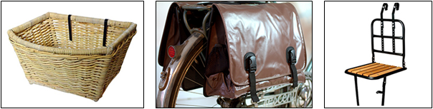
Please note, by sending photos in to the contest, you allow us to reuse the photos in conjunction with the EU supported CycleLogistics project.

9.7 Romania
In Romania two “Shop by bike” campaigns will be carried out. One will take place in Alba Iulia, and the second one in Blaj, which is situated near Alba Iulia, in Alba County. The “Shop by bike” campaigns will be carried out for 4 weeks each, between June and October.
For these campaigns we will target 200 people, which will use a bike to the supermarkets (Kaufland, Profi, Dedeman, Marketplace). We have chosen these locations because in these parts of the cities there is the necessary infrastructure to ride bicycles and small cargo bikes.
There are bike lanes which connect some neighbourhoods of the city with these supermarkets so is quite easy to use your bike when you shop at these supermarkets and at the marketplace. An additional criterion for the selection of the supermarkets was the availability of bicycle parking facilities.
In total 200 people will be involved in the campaigns, 100 in each campaign. The campaigns will be carried out with the help of volunteers from the “1 Decembrie 1918” University and from PAEM Alba Foundation which is a local non-governmental Organization. The volunteers will monitory these supermarkets during one week to see how many people use a bike instead of a car to go to shopping. Therefore, the volunteers will try to convince as many people as they can to use a bike instead of a car when they go to the supermarket by explaining all the advantages of using a bike for shopping.
In order to attract 200 people to use a bike we will give an incentive at the end of the campaign. As an incentive the participants will receive an Urbis Grates diploma through which the Mayor of Alba Iulia recognizes the merits of the participants that contributing to the welfare of the society.
These diplomas have a great impact in Alba Iulia. About 2 years ago the Mayor started to hand out such Urbis Grates diplomas to citizens such as craftsmen, tailors, shoemakers, that had shown loyalty for the community. Ever since the diplomas have been given to members of the community a competition started among citizens and the sense of responsibility for the community increased. Recently people try to be more dedicated and to be more involved in the community life in order to receive this diploma, which states their merits.
The diploma will therefore be a good incentive for the people to get involved in these Shop-by-bike campaigns. After the campaigns the Mayor will organize a ceremony in order to award the diplomas to the test shoppers.
The Municipality will provide 15 small cargo bicycles, which were donated last year, and the rest of the people will ride their own small cargo bicycles.
The campaign participants have to shop by bike as much as they can during one month. At the end of the campaigns an evaluation will be carried out by applying the questionnaire from the Monitoring and Evaluation Plan. Additionally our Research Institute will elaborate another questionnaire containing complementary questions specifically targeted to local needs.

9.8 The Netherlands
Shop by bike campaign action plan
Partner : IBC
Country: the Netherlands
Application area 3 private goods transport
Goal of the campaign
Central goal of the campaign is to change behavior of the target group when it comes to shopping . The target group is twofold and exist of those who do most of their actual shopping by car, and those who do shopping by bike but could use their bike more frequently or efficient. The campaign “shop by bike” aims to convince people to do most of their shopping by bike instead of by car.
Another goal besides change of attitude is to change awareness among target group by dissemination of information. The idea is that by giving arguments for shop by bike, the target group will stay motivated for a longer period than the actual campaign period.
In concrete the campaign will include 2 campaigns where per campaign 100 persons are expected to participate.
Implementation.
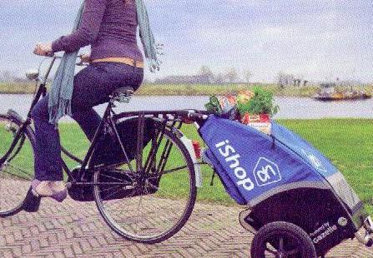
In the Netherlands, the “Shop by bike” campaign will be carried out in Utrecht and Houten. Cyclelogistics will get into contact with municipalities, the Dutch cyclist union, supermarkets, retailers, shop owners, etc. in order to promote a more attractive infrastructure for bicycle users (e.g. especially near the main entrance). Lobbying should lead to better infrastructure for people who want to do their shopping with bikes. In the Netherlands already much shopping is done by bike. However improvements can be expected by facilitating promotional activities by supermarket chains, to show their estimation of customers coming by bike to the shops. Municipalities play also a role as public domain is in their portfolio.
1 bike shopper (photo: Vogelvrije Fietser H Gijsman)
Planning
Two shop campaigns are planned for 2013. One in Houten planned for June and in Utrecht in September. The municipalities will play an important role together with the local branches of the Cyclist Union. The Cyclist Union will play a role in localozation of participants while the municipality will facilitate and support the campaign with publications and (political) support.
In the Dutch case shopping by bike is already a well-known issue. Nevertheless in many city areas outside the city centres the car is a significant mode of transport when it comes to shopping.

planning | Activity | Result | criteria | report | who
March | First meetings with Municipalities | Agreement on cooperation and support | Agreement about actions and responsibilities | Internal minutes | IBC, representatives from municipalities
 | First meetings with cyclist unions local branches | Agreement on cooperation and support | Agreement about actions and responsibilities | Internal minutes
April | Contacts with retailers and other stakeholders | Participation and involvement | Agreement about actions and responsibilities | Internal minutes | Retailers, shop owners, bicycle shops
April | Development of publicity materials | Publicity materials | Leaflets, gadgets | Publication material | IBC, publicity Municipality
 | First announcement in local media | Articles, |  | no | IBC, Cyclist Union, Municipality
May | Development and printing of materials | Materials | Definition of quantities | No
May | Preparation of press release | Press messages
June | Preparation of materials for participants | Materials | Cost and numbers | No | Bike shop owners, IBC, retialers
 | Actual campaign Houten | 100 particpants | Number of participants |  | IBC, cyclist union, Municipality, others
July | At the end fil in questionaires | High response of filled in questionairs | Good participation and attitude change | yes | IBC
August | Evaluation of 1th campaign |  |  |  | IBC and stakeholders
September | Campaign in Utrecht | 100 particpants | Number of participants |  | IBC, cyclist union, Municipality, others
End October | Finalization campaign Utrecht. Surveys to be filled in.
November | Evaluation of NL campaigns | Final report |  |  | IBC with input from stakeholders
December January | Article(s) based on evaluation | Article(s) on website, local media, national reviews. |  |  | IBC
Expected output of the campaign
First of all it is expected that the participants of the campaign have changed their attitude and actual shopping behavior towards a positive approach for shopping by bike.
Also it is expected that by means of media coverage and side effects of the campaigns that more than the 200 foreseen participants will have changed attitude to shop by bike.
Another effect expected is with the group of shop owners and retailers in such a way that more attention is paid to cycle parking facilities near shops.
By facilitation of trailers, bags, cargo bikes and other facilities it is expected that more of these products will be used to support shopping by bike.
For sustainability of the campaign attention should be paid at the end of the evaluation to continue or repeat the campaign in 2014.

9.9 Slovenia
The Shop-by-bike campaigns in Ljubljana, Slovenia will be carried out in a similar way as in Austria. Both campaigns are planned for spring 2013

9.10 France

9.11 Croatia
The Shop-by-bike campaign in Koprivnica, Croatia, will be carried out in a similar way as in Austria. The campaigns are planned for spring and autumn 2013

10. Annex - Best practice examples

Belgerinkel
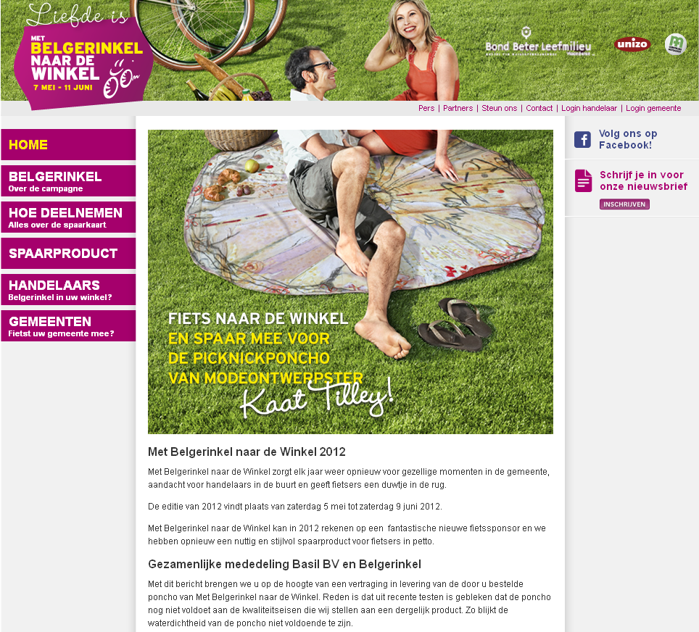
Figure 6: Belgerinkel website
The campaign “Belgerinkel naar de winkel“ or in English „Bell Ringing to the Shop“ is the biggest bicycle campaign in Belgium and engages people in more than 180 Flemish municipalities. For 6 weeks every year people can cycle to different shops to collect stamps and win prizes. The campaign is organised by Bond Beter Leefmilieu (BBL) in cooperation with the Union of Small Businesses (UNIZO), the Christian Health Insurance (CM) and the Cyclist’s Union. (www.belgerinkel.nl)
The aim of the campaign is to convince the broad public to do their daily shopping by bike and not by car and to visit more local shops instead of out of town shopping centres. This way every cycling customer contributes to improve air quality in inner cities helps to make the roads safer and to support small businesses.
Already in 2002 43 local communities and 3500 merchants joined the campaign and in 2008 these numbers had increased to 183 communities and 15500 merchants. More than 113000 campaign participants cycled almost 6 million kilometres (or 157 times around the world. This campaign managed to reach an impressive 3,2 million Belgians.
The year 2009 saw an entirely new concept for the campaign: Every participating cycling customer was able to save up for his or her bike bag that was designed by a famous Belgian Fashion designer. Every time customers were out shopping with their bikes they were able to collect a stamp on a card from a participating merchant. With a full card they were able to order the designer bag for a reduced price. In 2012 the prize will be a picnic poncho that can be used by cyclists as picnic placket or a rain cape.

Bicycle delivery Service in Switzerland
In 10 cities in Switzerland (including Zurich) there exists a home delivery service for customers. (http://wir-bringens.ch/hauslieferdienst/index.htm). This service started in Burgdorf a city with 15.000 inhabitants. Customers can leave their heavy shopping bag in the shop and their shopping will be delivered to their home address within a maximum of 3 hours or at any other agreed time. The tariffs for the delivery service vary from town to town, but in Burgdorf customers pay Sfr 3.- per delivery or they have an annual ticket for Sfr 150., The participating shops contribute Sfr 2.- per delivery (or Sfr 1.- after the 1000 delivery, respectively).

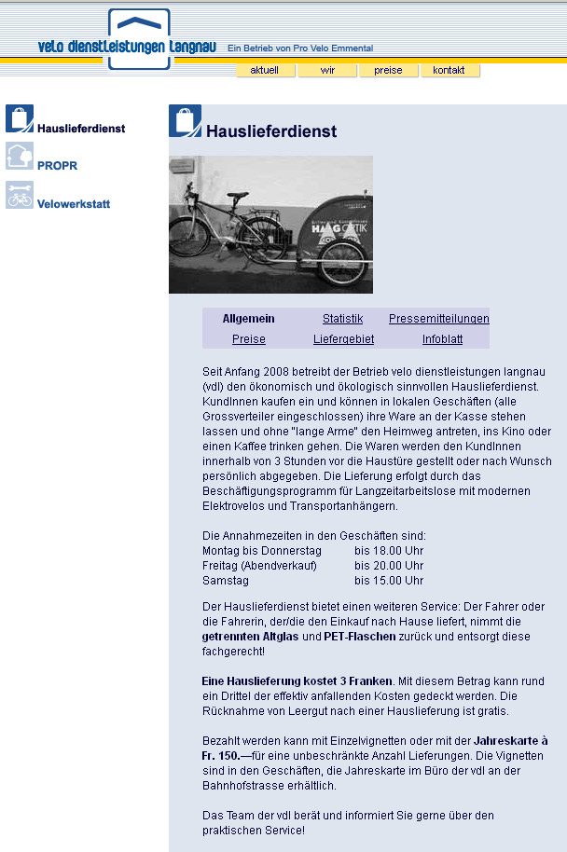
Figure 7: Home delivery service
The service is very successful as the numbers from Burgdorf indicate below:
Number of deliveries in November 2011 | 2.161
Total number of deliveries since the introduction of the scheme in September 1997 | 247.369
Average number of deliveries per day (2010) | 82
Average number of delivered bags per day (2010) | 141
Daily record: Thursday, 23. December 2010 | 167
Number of participating shops | 40
Delivered bags 2010 | 44.435
The customers using this service are not so much senior citizens but mostly families of the upper to middle class.
The deliveries are carried out in cooperation with an employment programme for long-term unemployed people, with modern e-bikes and bicycle trailers
The shops do not require a lot of space to store the shopping bags because a person from the delivery service collects the bags regularly and delivers them to a central storage point (2m² for 6 – 10 customers). The storage area is a movable shelf (joint development of COOP and Migros). The courier can move this shelf from the shop to the bicycle trailer and unload it. This prevents the shopping goods to be damaged and saves time. For most of these deliveries a cooling system for the shopping goods is not necessary.
A special shopping bag has been developed for this delivery service. It has a transparent window for the dispatching note (delivery address, delivery time and other additional information) and for the „postage stamp“ as proof for payment, because the couriers are not allowed to handle money. The delivery is paid in advance during the shopping trip or through the yearly ticket. The bicycle couriers also return empty containers to the shops, if needed. The programme is financed as follows:
- Sponsoring: company logos on bicycle trailers, clothing, bicycles, delivery notes and shopping bags.
- Social welfare money
- Financial support for bicycle initiatives
- Proceeds from deliveries
For the customer and the participating shops the processing of the deliveries is very easy, but the organisation of the service itself is quite demanding. The couriers are supervised and supported by psychologists or social workers. For peak times or in case a courier is absent due to illness there is an arrangement with commercial delivery services in place and also with mobility car sharing.
This programme will be implemented in Salzburg (Austria) by the supermarket chain SPAR. At the beginning they are planning to have 6 to 8 couriers and 1 coordinator leading to personnel costs of €240.000,-and 100m² for the headquarter. The couriers will be provided with warm durable clothing and will continue to ride in winter. Bicycle trailers and bikes have to withstand a lot of stress. The e-bikes will need about 1 battery per year.
The best couriers in Switzerland cycle up to 10.000 km per year!

